Hanna Chang

COSC 412

**Software Project Management Plan “Thrive2bemindful”**

**Table of Contents**

1. **Introduction**

1.1 Project Overview

1.2 Project Deliverables

1.3 Evolution of the SPMP

1.4 Reference Materials

1.5 Definitions

1. **Project Organization**

2.1 Process Model

2.2 Organizational Interfaces

1. **Managerial Process**

3.1 Management Objectives

3.2 Assumptions, Dependencies, and Constraints

3.3 Risk Management

3.4 Monitoring and Controlling Mechanisms

1. **Technical Process**

4.1 Methods, Tools, and Techniques

4.2 Software Documentation

1. **Description of Work Packages**

5.1 Work Breakdown Structure (WBS)

1. **Introduction**

**1.1 Project Overview**

Due to COVID-19, many people have suffered tremendous losses that result in deteriorating mental health. This website was created to assist the millions of people that struggle with mental illness, but do not have access to treatments or are not ready to seek help. With many practices becoming overloaded with patients and inabilities to pay for treatments, there is a high demand for cost efficient and free ways to seek help. This site will provide resources to learn about mental illnesses, tips and activities to improve mental health, and further resources if more help is seeked. Users will be able to utilize the site to learn about mental illnesses and how they can be more mindful of themselves or those who are struggling in their lives.

**1.2 Project Deliverables**

* Project Proposal: September 5, 2020
* Use Cases Document: September 22, 2020
* Project Requirements: September 25, 2020
* SPMP: October 1, 2020
* Tool Selection: September 25, 2020
* Work Breakdown Structure: September 20, 2020
* Gantt Chart: September 30, 2020
* Initial Prototype:
  + Home page: October 20, 2020
  + Learn page: October 20, 2020
  + Resources page: October 20, 2020
  + Activities page: October 20, 2020
  + Dashboard page: October 20, 2020
* Depression Forum: November 15, 2020
* Anxiety Forum: November 15, 2020
* Post Traumatic Stress Disorder Forum: November 15, 2020
* Substance Abuse Forum: November 15, 2020
* Testing Plan: November 20, 2020
* Conduct Testing: November 29, 2020
* Website release: November 29, 2020

**1.3 Evolution of the SPMP**

My lack of skills in coding in languages that are new to me required changes in my tools. It was originally planned to create the user interface using React, but my skillset of coding was not there. It was a much more viable choice to use a content management system, so using Wordpress instead of React was an anticipated change. This content management system made it much simpler to create the components of the site. Another change in tools was from Bluehost to Siteground. Bluehost was the original hosting company that was planned to be used until speaking with peers to find out there were many issues. After researching hosting companies, Siteground was a useful tool to use. After the site release, there are unanticipated changes to come based on hosted interviews with users. The site must be user-friendly and be adaptable to user needs. It is planned in the use cases to maintain the other tabs and sections of the site. Any unanticipated changes will be assessed and added to the task breakdown and scheduling to ensure it is completed in a timely manner.

**1.4 Reference Materials**

* Anxiety Disorders. (n.d.). Retrieved November 18, 2020, from <https://www.nimh.nih.gov/health/topics/anxiety-disorders/index.shtml>
* Bradford, L. (2020, October 13). How to Install WordPress on Your Mac Using MAMP. Retrieved November 18, 2020, from <https://skillcrush.com/blog/install-wordpress-mac/>
* COSC 412 Week 4 slides
* Depression. (n.d.). Retrieved November 18, 2020, from <https://www.nimh.nih.gov/health/topics/depression/index.shtml>
* Gantt chart template <https://monday.com>
* Post-Traumatic Stress Disorder. (n.d.). Retrieved November 18, 2020, from <https://www.nimh.nih.gov/health/topics/post-traumatic-stress-disorder-ptsd/index.shtml>
* SiteGround WordPress Setup Tutorial For Beginners - New 2020 Interface. Retrieved November 18, 2020, from <https://www.youtube.com/watch?v=8c3QupBIVfA>
* Substance Use and Mental Health. (n.d.). Retrieved November 18, 2020, from <https://www.nimh.nih.gov/health/topics/substance-use-and-mental-health/index.shtml>
* <https://www.aaf.org/_pdf/aaf%20website%20content/513_ethics/iae_principles_practices.pdf> - Institute of Advertising Ethics Principles and Practices
* Unsplash. (n.d.). Beautiful Free Images & Pictures. Retrieved November 21, 2020, from <https://unsplash.com/>

**1.5 Definitions and Acronyms**

* WBS: Work Breakdown Structure
* PTSD: Post traumatic stress disorder
* Learn tab: the section of the website that provides information about the common mental illnesses suffered throughout the pandemic and in general.
* Resources tab: the section of the website that provides information on seeking further help, hotlines, and further resources.
* Activities tab: the section of the website that provides tips and activities that lead to improved mental health

1. **Project Organization**

**2.1 Process Model**

This project will utilize the waterfall model. This model will allow each phase to be broken down and displayed in chronological order. The phases include planning, initial prototype, construction, and testing and deployment. The requirements of the phases are organized by start dates and deadlines that depicts a waterfall pattern.

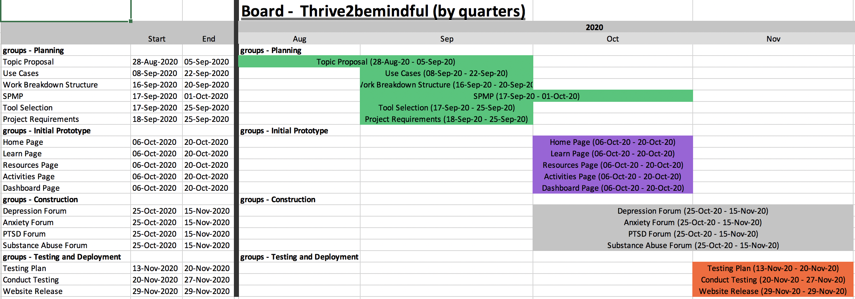

**2.2 Organizational Interfaces**

I will develop and maintain the website. Relations with other entities will include client interviews and meetings to get feedback on desired changes and amenities. This will allow me to improve the site and cater to the user’s wants and needs. I will also be in contact with current and potential advertisers, the alternate form of profit aside from user subscriptions. There will be

anticipated change with the use of different hosts and database tools.

1. **Managerial Process**

**3.1 Management Objectives and Priorities**

* Create and update project documentation of requirements, tools, planning, cost analysis, risks, and any anticipated and unanticipated changes
* Keeping up with deadlines to ensure the project is completed by the client’s desired time.
* Organizing regular client meetings to keep the client informed and to receive feedback
* Ensure that the developed software meets HL mandates
* Keeping track of major development changes
* Testing the site regularly to maintain functionality

**3.2 Assumptions, Dependencies, and Constraints**

* Constraint:
  + The project must have a working prototype by November 29, 2020 to present functionality
* Contingency:
  + Scheduling tasks and setting deadlines for each section of the project to ensure that all components will be completed on time.
* Constraint:
  + There is no budget or funding.
* Contingency:
  + All development will be done using open-source software for implementation. Tools used must be priced affordably or free.
* Constraint:
  + I lack a strong coding background.
* Contingency:
  + Without extensive coding experience, it was necessary to have a strong understanding in finding other methods to create a website through research. The best option was to use a content management system, like Wordpress, to assist me in the development of the site without having to code all the components.
* Constraint:
  + The users will all have different experiences and difficulties with their mental health.
* Contingency:
  + The site will contain information on numerous mental illnesses as well as activities that will benefit a variety of people and issues.
* Constraint:
  + Information and recommendations must be accurate and safe.
* Contingency:
  + A disclaimer should be used to notify users that this is not a medical or professional treatment, but a resource and additive to benefit mental health. The disclaimer should also inform users to seek further help if symptoms are serious and threatening for both the user’s safety and protecting my site from any legal complications.

**3.3 Risk Management**

* Risk:
  + Due to COVID-19, everything must be remote including development and meetings with clients.
* Contingency:
  + Remote meetings must be scheduled with clients and an interface must be chosen and set up to host the remote meeting.
* Risk:
  + Users will enter login information when signing in or creating an account that could be compromised if breaches occur.
* Contingency:
  + The information entered should be stored securely in a database that will be protected with security tools.
* Risk:
  + All the desired components of a website may not be available as plugins on the content management system.
* Contingency:
  + The provided plugins must be tested to ensure that they are updated and functioning properly.
* Risk:
  + Users may try and access the Wordpress dashboard to make changes.
* Contingency:
  + Settings on Wordpress should be set so that only registered administrators are able to make changes to the site.

**3.4 Monitoring and Controlling Mechanisms**

Scheduling of important milestones are closely monitored with an online scheduler. The Gantt chart includes important deadlines that are listed along with project needs and tasks to be able to visually understand and remember what needs to be completed. There are meetings with the professor and milestone reviews to ensure that the project is on track with the schedule and necessary tasks are completed. Additional meetings are also scheduled as needed for guidance and progress checks.

1. **Technical Process**

**4.1 Methods, Tools, and Techniques**

* The website will be developed to run on all common browsers including Google Chrome, Safari, Firefox, Internet Explorer, etc.
* The website will be made from a template on Wordpress.
* Elementor is used to develop the user interface.
* Canva will be used for the logo.
* Unsplash will be used for free images.
* The database will be stored in phpMyAdmin.
* Hosting will be done through Siteground.

**4.2 Software Documentation**

A project requirements document will document all the necessary components of the website’s development. It is important to lay out all the requirements prior to the development of the project to ensure all components needed to utilize the site are created. This documentation will include the functionality as well as visual components of the site.

A use case document will contain the possible scenarios that users will carry out. For example, the actions of a user that is logged in will differ from the actions of a user creating an account.

The tools document will lay out all the tools used for the project and what it is used for. This document will display what content management systems, databases, hosting, and other resources were used to create the project.

A system test procedure will contain the end-to-end testing methods to ensure functionality of all components of the site.

The Gantt chart is a visual representation of the schedule to ensure all tasks of the project are started and completed at the scheduled dates for efficient time management and that the site will be ready to be deployed by the deadline.

1. **Work Breakdown Structure**

